**SETTING UP PROJECT**

1. Verify you have Visual Studio 2019 – Community Version installed on computer. If not, find it here: <https://visualstudio.microsoft.com/vs/>
2. Download current project from GitHub as ZIP file.
3. Right click on download and select “Extract All”
4. Once extracted, double click on OnlineClothingStore.sln
   1. This will automatically set up the project in VS 2019
5. Once open, click on “File” in the top-left
6. In the dropdown, click “Open” and then “File”
7. Select “DatabaseSetup” in the folder downloaded from github
   1. This will set up the SQL server database needed for the project.
8. Once opened, click on ***hollow*** green play button to run SQL program
   1. Correct run button:

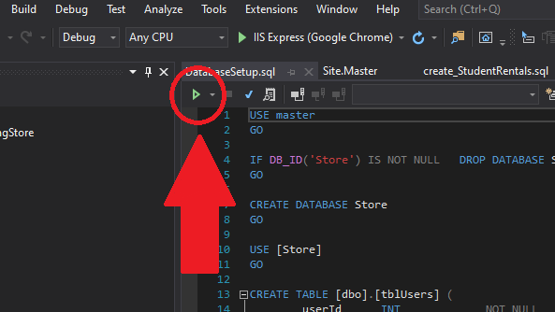

Once this has been run, everything for project should be ready to go in the IDE. Make sure to reupload files to github so that everyone has the most up-to-date files when editing. Also make sure to check off any tasks completed in github.